MEHRAN UNIVERSITY OF ENGINEERING & TECHNOLOGY JAMSHORO

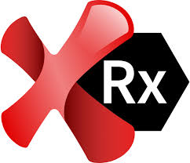

Subject: Software Construction and Development

(Lab 10)

A Project of Testing Tools

**Guideline:**

|  |  |
| --- | --- |
| **Roll No:** | **22SW028** |
| **Section:** | **I** |
| **Name** | **Arbab Hussain** |

Compare any 5 testing tools, their features and draw a table of their comparison along with correct references, but references should be of 2024 and 2025

Testing tools in 2025 address diverse needs, from performance and API testing to browser automation and GUI validation. Below, I have compared and contrasted five testing tools based on multiple factors.

These five tools are

1. Apache JMeter
2. Postman
3. Selenium
4. Ranorex
5. Soap Ui

1. **Apache** **JMeter**

* **Definition**: Apache JMeter is an open-source tool designed for load and performance testing, simulating multiple users to assess the scalability and responsiveness of web applications, servers, and databases.

**Strengths:** Its GUI simplifies test creation, while Java scripting offers customization [1]. Seamless integration with CI/CD tools like Jenkins ensures scalability [2].

**Limitations:** Non-technical users may find the technical setup challenging.

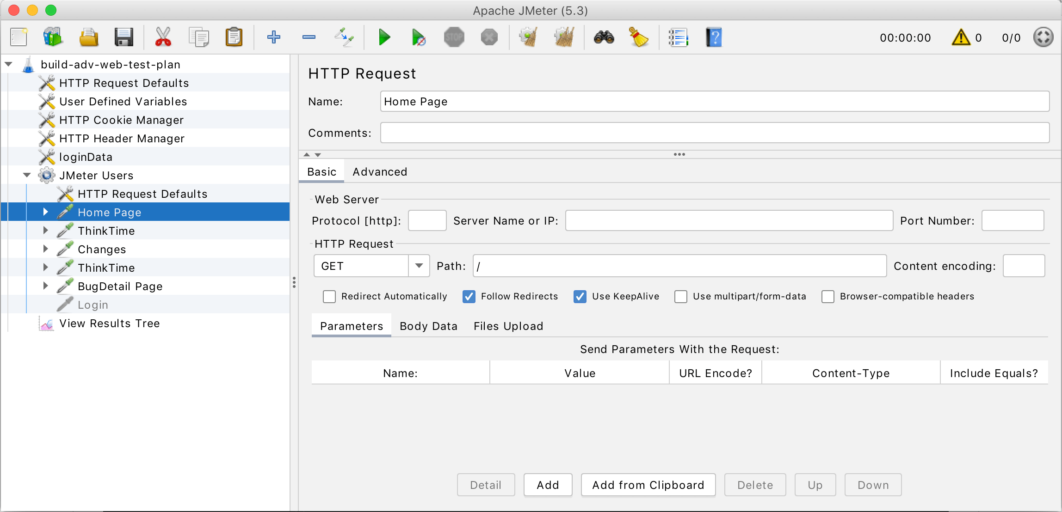

**2. Postman**

* **Definition**: Postman is a widely-used platform for API testing, enabling users to send requests, validate responses, and automate workflows with an intuitive interface, ideal for API development and monitoring.
* **Strengths:** An intuitive interface supports API mocking and monitoring [3]. Newman integration enables CI/CD workflows [4].
* **Limitations:** Focused solely on APIs, not suited for UI or broader testing.

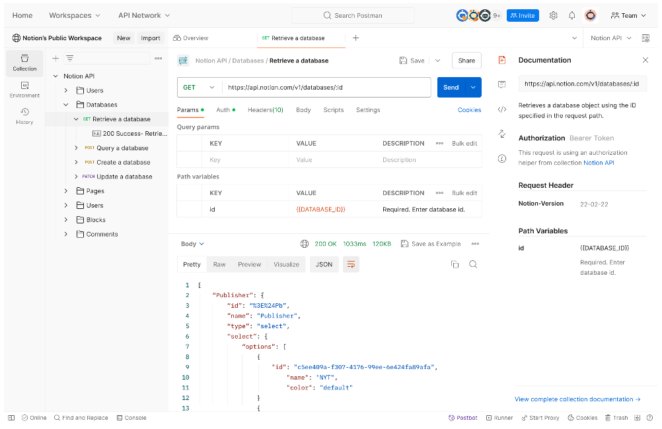

**3. Selenium**

* **Definition**: Selenium is an open-source framework for automating web browsers, allowing testers to script interactions across multiple browsers (e.g., Chrome, Firefox) to validate web application functionality.
* **Strengths:** Supports all major browsers (Chrome, Firefox, Edge) with multiple programming languages [5]. Integrates with DevOps tools like Jenkins and TestNG [6].
* **Limitations:** Requires coding skills and lacks native mobile/desktop support.

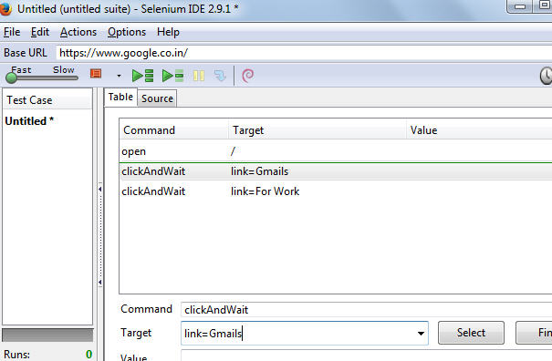

**4. Ranorex**

* **Definition**: Ranorex is a commercial test automation tool focused on GUI testing, offering codeless recording and robust object recognition for web, desktop, and mobile applications.
* **Strengths:** Test recording and object recognition make automation accessible [7]. Supports agile workflows with tools like Jira and TestRail [8].
* **Limitations:** Full functionality requires a paid license beyond trial.

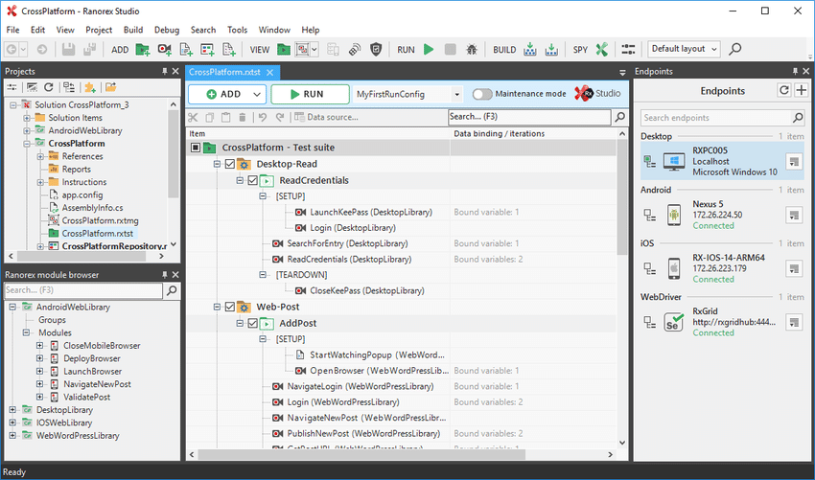

**5. SoapUI**

* **Definition**: SoapUI is a leading tool for API testing, specializing in SOAP and REST services, with features for functional testing, security scans, and service mocking, available in both open-source and paid versions.
* **Strengths:** Simplifies SOAP/REST testing and includes security scanning [9]. Strong CI/CD support via Jenkins and Docker [10].
* **Limitations:** Limited to API/web services, not UI or mobile testing.

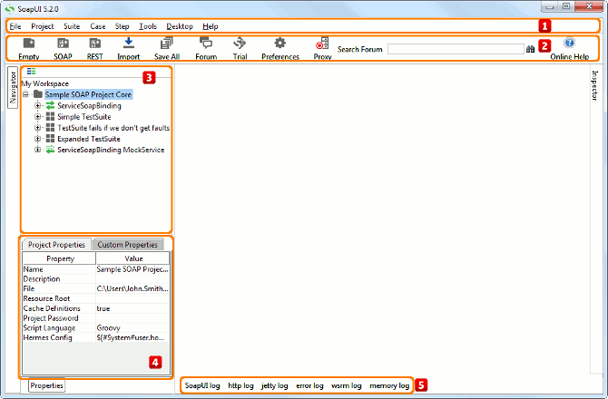

**COMPARISON TABLE:**

|  |  |  |  |  |  |
| --- | --- | --- | --- | --- | --- |
| **Testing Tool** | **Ease of Use** | **Supported Platforms** | **Programming Languages** | **Integrations** | **Unique Features** |
| **JMeter** | Moderate – GUI-based but technical; steeper learning curve for non-technical users [1] | Web, Server, Database – Ideal for load/stress testing [1] | Java (scripting) – Adds flexibility to GUI [1] | Jenkins, Maven, BlazeMeter – Automated performance checks [2] | Load and performance testing – Simulates heavy traffic [1] |
| **Postman** | High –  Intuitive UI, minimal coding; great for beginners [3] | API, Web services – Focus on API workflows [3] | JavaScript (optional) – For advanced scripting [3] | GitHub, Slack, Newman – Enables CI/CD [4] | API mocking, monitoring – Real-time API simulation [3] |
| **Selenium** | Moderate – Requires coding proficiency; setup can be complex [5] | Web only – Cross-browser testing [5] | Java, Python, C#, Ruby, JS – Multi-language support [5] | Jenkins, Docker, TestNG – DevOps compatibility [6] | Browser automation – Extensive browser support [5] |
| **Ranorex** | High –  Codeless option, user-friendly; simplifies automation [7] | Web, Desktop, Mobile – Broad GUI testing [7] | C#, VB.NET (optional) – For custom scripts [7] | Jenkins, Jira, TestRail – Agile workflow support [8] | Test recording, object recognition – Easy GUI automation [7] |
| **SoapUI** | High – Simple for API testing; quick setup [9] | API, Web services – SOAP/REST focus [9] | Groovy (optional) – Extends functionality [9] | Jenkins, Docker, Load UI – Robust CI/CD [10] | SOAP/REST testing, security scans – Validates services [9] |

**References / Bibliography:**

[1] "Apache JMeter: User Manual 2025," *Apache JMeter Official Site*, February 10, 2025.

URL: <https://jmeter.apache.org/usermanual/best-practices.html>​

[2] "Top Performance Testing Tools for 2025," *BlazeMeter Blog*, March 15, 2025.

URL: <https://www.blazemeter.com/blog/performance-testing-tools>

[3] "Postman Learning Center: API Testing 2025," *Postman Official Docs*, January 25, 2025.

URL: <https://learning.postman.com/>​

[4] "API Testing Trends in 2024," *Test Guild*, December 20, 2024.

URL: <https://testguild.com/automation-testing-trends/>

[5] "Selenium Documentation: 2025 Updates," *Selenium Official Site*, March 5, 2025.

URL: <https://www.selenium.dev/blog/2025/selenium-4-28-released/>

[6] "Top Automation Testing Tools for 2025," *HeadSpin Blog*, January 30, 2025.

URL: <https://www.headspin.io/blog/the-ultimate-list-of-automated-testing-tools>​

[7] "Ranorex Studio: What’s New in 2025," *Ranorex Official Blog*, January 15, 2025.

URL: <https://support.ranorex.com/hc/en-us/articles/22490858109981-Ranorex-Studio-Release-Notes-12-1-2>​

[8] "Automation Tools for Agile Teams 2025," *TestRail Blog*, March 20, 2025.

URL: <https://www.testrail.com/blog/automation-in-agile-strategies/>​

[9] "SoapUI: API Testing Guide 2025," *SmartBear Official Docs*, February 28, 2025.

URL: <https://smartbear.com/resources/ebooks/beginners-guide-to-rest-testing/>

[10] "Best API Testing Tools in 2024," *HeadSpin Blog*, November 10, 2024.

URL: <https://www.headspin.io/blog/top-20-tools-for-api-test-automation-for-effective-software-testing>